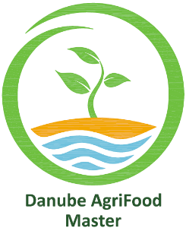
Erasmus Mundus Master Program - Danube AgriFood Master

DECLARATION ON HONOUR

I, the undersigned, __________________________, hereby certify and declare on my honour that:
[lastname, firstname]

- All information and documents provided in the Danube AgriFood Master (DAFM) Application form are complete, true and accurate.

- I hold an undergraduate/bachelor degree or equivalent in the requested field of study, or I will hold it at the time of enrolment.

By signing this declaration, I acknowledge that:
- In case of fraud or false declarations in the application form and submitted documents, I will be automatically excluded from the selection process;

- In case I am selected and afterwards identified as not eligible because of fraud or false declaration, I will have to reimburse the costs spent by the Coordinating Institution related with my participation in this Programme.

- In case I am selected with an Erasmus Mundus scholarship, I commit not to benefit from another EU funded scholarship scheme to follow the same EMJM course for the entire period of the course.

- I acknowledge the fact that if I am selected (proposed for a scholarship/fellowship, put on the reserve list or enrolled on a self-paying basis) my personal data may be used for the purposes of evaluating the programs, efficiently manage the projects, and producing statistics. Data could be made available to the DAFM Consortium, the EACEA, the European Commission, the European External Action Service staff, as well as to other stakeholders of the Erasmus+ program, such as Erasmus+ National Agencies, National Erasmus+ Offices and the Erasmus Mundus Student and Alumni Association

Date:

Signature:

