Danube AgriFood Master – DAFM
Background and general objectives
Our DAFM program aims to educate students, who are sensitive to sustainable agriculture and food production. To enhance the safety and stability of food production beside sustaining the environmental resources and eco-system services is crucial for adaptation to climate crisis, overpopulation and natural resources depletion.
The 120 ECTS joint degree MSc “Sustainability in Agriculture, Food Production and Food Technology in the Danube Region” (Danube AgriFood Master – DAFM) focuses on sustainable development as competent response to the upcoming challenges climate change and protection and promotion of livelihoods. It uses the Danube region as a model region for all riparian regions worldwide.
It combines the unique expertise of the HEI-consortium to provide top-quality research based education in sustainable agriculture, food security, food production and technology as core contents. It provides a solid basis in all relevant disciplines from natural sciences, engineering, economics to social sciences, offering extensive opportunities for interdisciplinary approaches and intercultural communication and promotes the idea of sustainable bioeconomy.
DAFM program offers the following ADDED VALUES in response of the identified needs:
-The program addresses globally hot issues, namely food safety, sustainability, and climate change. While European consumers tend to be conscious with food products, for developing countries the topics including water and soil issues are important in regard to their further development.
-The DAFM project offers an overarching, interdisciplinary academic program, where students will acquire the „from stable to table” or „field to fork” approach. Repeatedly, the EU’s General Principles of Food Law has to be quoted. The general objectives of the food law aim to ensure a high level of protection of human life and health, while taking into account the protection of animal health and welfare, plant health, and the environment. This integrated "farm to fork" approach is now considered a general principle for EU food safety policy.
-DAFM puts emphasis on food system approach: “Highly connected commodity markets affect the global environment and food security. Solving problems of food insecurity and loss of ecosystem services must therefore be based upon understanding complex interactions among multiple processes. Systems-based approaches are needed to help deliver this understanding.” (P. Ericksen et al: The Value of Food System Approach in Food Security, Food Systems and Global Environmental Changes). This concept is embedded both in courses and practice like ecological-social gardens.
- Since the majority of Central and Eastern European countries are members of the EU and familiar with relevant EU regulations, the systems of certification and accreditation are also a prerequisite for today’s agricultural producers. This issue is addressed both in the framework of specific courses and in summer/winter schools. Developing countries may use this knowledge to shape their own country’s systems.
The gained knowledge and skills are supposed to be transferable to other riparian regions, as the Danube region is the world’s most international river basin as largely EU space. It starts in mountain regions in higher altitude, passing different geological and agricultural areas down to the broad river delta at the black sea. It combines different agricultural land, different food production areas with different food technologies. It passes through different weather zones, it faces problems arising by extreme weather events like floods, hail, storms typical for big river basins as well as soil erosion which is considered as the major and most widespread form of soil degradation worldwide. There are new opportunities to address its challenges and potential, especially to overcome the ecological and economic crisis in a sustainable manner. Socio-economic development, competitiveness, environmental management and conservation of biodiversity combined with resource efficient growth can be improved and security and transport corridors modernized. The Danube and the DAFM Master can open the EU to its near neighbors, the Black Sea region, the South Caucasus and Central Asia, thereby increasing the attractiveness of the European Higher Education area.

About the partner HEI-s and the Curriculum
The offer is made by a well-established, competent consortium of leading academic institutions covering Central and South Eastern Europe region and a long-term experience in carrying out joint projects.
Full partners (offering the DAFM Joint Degree) are the Hungarian University of Agriculture and Life Sciences (MATE) (HU), the Czech University of Life Sciences Prague (CZU) (CZ), the University of Natural Resources and Life Sciences, Vienna (BOKU) (AT), the Slovak University of Agriculture Nitra (SUA) (SK), the University of Zagreb (UNIZG)(HR), the University of Novi Sad (UNS) (RS) and the Banat‘s University of Agricultural Sciences and Veterinary Medicine, Timisoara (BUASVMT) (RO).
Associate partners are HEIs, public authorities and business stakeholders including small-, medium- and large- sized enterprises.
Partners and several associated partners are members of the Central European Network of Life Science Universities (CASEE), have a long history of cooperation and are partners in other university networks worldwide.

Curriculum structure:
DAFM is a two-year (120 ECTS) master's program offered in English with contributions from all full and associate partners to the joint start-up module and all courses, including one compulsory joint summer or winter school, where all DAFM students meet every year.
From the first semester onwards, DAFM students are enrolled at each full partner university. They spend their first and second semester at MATE (Gödöllő) and CZU (Prague) to gain basic knowledge for the designed program, for the third and fourth semester students can choose between BOKU, UNS, UNIZG, SUA and BUASVMT. The fourth semester is essentially dedicated to the Master Thesis, thus the student may choose topic from the second year Universities, the first-year universities are providing a co-supervisor for supporting the Master Thesis and for a deeper cooperation between the two full partners. In this way the Master Thesis is always supervised by a teacher of the second-year host university and co-supervised by the first-year university.
All DAFM students must attend at least one compulsory joint winter/summer school. The program includes an obligatory participation in a scientific conference for 2 ECTS (e.g. CASEE Conference which takes place at a CASEE member university each year) and an obligatory internship (100 working hours) for 4 ECTS. These internships are primarily offered by the associated non-academic partners of the consortia.
Mobility track of the DAFM program
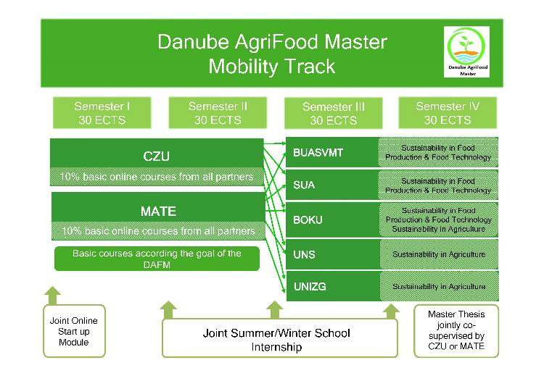

Composition of curriculum
The curriculum consists of 4 Focus Areas with compulsory and elective courses:
- FA1: Food safety and consumer science (BOKU, MATE, BUASVMT, SUA, CZU)
- Biotechnology
- FA2: Sustainable agriculture (BOKU, MATE, BUASVMT, UNS, UNIZG, CZU)
- Biotechnology
- Biodiversity and sustainable use of natural resources
- FA3: Soil, water and climate (MATE, BUASVMT, UNS, UNIZG)
- Sustainable energy systems
- FA4: Intercultural learning (MATE with contributions from all full partners)
- Sustainable, rural and regional development and policy
- Regional specialties
The compulsory subjects are from the bold highlighted Focus Areas (curriculum website). In the framework of FA4, students will participate in one compulsory summer/winter school (4 ECTS) where all DAFM students meet, a compulsory internship with 100 working hours (4 ECTS) and a subject on scientific communication including a real conference participation for 2 ECTS.
For the learning outcomes, DAFM graduates will receive the following competencies:
- Excellent knowledge of agriculture and food production under the aspect of sustainability in a divers river basin region like the Danube Region and possibilities of transferability to other river basin areas worldwide.
- The ability to network and exchange the most actual knowledge in the field of agriculture, food production and food technology under the aspect of sustainability.
- An understanding of the principles of sustainability, especially for any river basin.
- An understanding of the general development of a river basin seen from ecology, rural development and cultural history side.
- The capability to critically select and apply adequate methods for sustainability in agriculture, food production, and food technology.
- The ability to analyze social interactions in an intercultural context. They will be aware of intercultural differences and misunderstandings that might result out of these. Graduates will achieve an open- mindedness towards persons with other nationality/religion/culture. Due to the intercultural competence achieved, graduates will be able to be solely responsible for guiding international project teams.
- Mastery of the English language and exposure to one or more other languages of the countries involved in this master program with the opportunity to active learn one of the languages.
- The opportunity to convey research proposals, reports, and scientific papers to a wider public audience.
In addition to the general learning outcomes, the DAFM curriculum focuses on four key issues, or project Focus Areas:
- Food safety and consumer science: graduates will be familiar with strategies, requirements and potentials of food microbiology. Fundamentals of food chemistry are connected for an in-depth knowledge of mechanisms and interactions regarding food safety and quality. Graduates will have an overview of state-of-the-art molecular methods and will be familiar with selected examples in practical application. Graduates will possess the qualification to assess product quality. Graduates will understand practical problems and activities in food production.
- Sustainable agriculture: graduates will be able to investigate, critically analyze and understand the challenging nature of agriculture in order to plan and solve problems relating to sustainable agriculture. Moreover, they will be able to demonstrate an understanding of the dynamic nature of agricultural knowledge and of the appropriate technology, as well as to interpret and apply this knowledge to agricultural management practices and systems to ensure a sustainable agricultural environment.
- Soil, water and climate: graduates will learn the most important characteristics and functions of the atmospheric systems and agro-meteorology. Graduates will be aware of problems arising from climate change and know their effects on agriculture, as well as which atmospheric processes (on a scale of time and space) are relevant or dangerous for agricultural processes (e.g. extreme weather events). Graduates will understand the relationship between soil, water, and climate, and the influence of agricultural methods on especially the soil. They will acquire advanced knowledge in land and water resources management, taking into account soil suitability on the basis of soil survey and physical characteristics, danger of soil erosion and water movement in the soil, and water availability in relation to climate and its effects on plant growth.
- Intercultural learning: graduates will apply knowledge and critical thinking to global and cultural issues, trends, systems and will use diverse frames of reference to address problems.

For the selection of students, in accordance with the E+ selection rules for Joint ERASMUS+ Master Programs, the following application criteria will be used:
- Previous studies (bachelor degree, diploma, plus transcript stating subjects, marks, ECTS from previous studies) Students of selected bachelor’s programs are admitted directly to the Master program
(http://ica-casee.eu/index.php/casee-master/application-admission)
For graduates of bachelor’s programs which are not listed on the above website, bachelors of the following learning outcomes (evidenced by ECTS) are required for admission. At least 60 ECTS from the following areas:
- Natural science: min. 20 ECTS
- Plant production: min. 10 ECTS
- Animal Science: min. 10 ECTS
- Economic Sciences: min. 10 ECTS
- Technological Sciences min. 8 ECTS
- English Language Proficiency
  - English Language Skills at level B2 of the Common European Framework of References for Languages (CEFR) or equivalent tests (see website mentioned above) are required. (Skype interviews can take place with the candidates to prove their English language abilities)
- Filled and signed Application form
- CV
- a copy of their passport
- The weighting of the various criteria is as follows:
  - previous studies and English language proficiency: 40-40%;
  - CV: 15 %,
  - Application form details: 5%
The Selection Committee will approve the new students under lead of the contractor in a meeting at the end of march. The contractor will send the final list of the new students to the EACEA.
Admission is granted to prospective students who meet the admission criteria which are stated in the joint Education and Examination Regulations. The Selection committee will select candidates for admission; and admission at one of the parties is automatically accepted at all other parties. Students in the program will be registered at each of the parties for the full duration of their studies as regular students, with full local student's rights and services.
This is done in due time before the student starts studies in the partner university in question and study fees will be charged if applicable.

Student examination, thesis defense and performance evaluation:
In general, the examination and evaluation regulations of the host university where the student is currently studying prevail.
The fourth semester is essentially dedicated to the Master Thesis. The Master Thesis is always supervised by a teacher of the host university of the second year and co-supervised by another expert from a first year university. The thesis defense is organized according to the rules of the university where the thesis defense takes place. The evaluation of the thesis is a combined grade of the Exam board and the main and co-supervisor.

Pictures from the everyday life at MATE’s Agro-Ecogarden
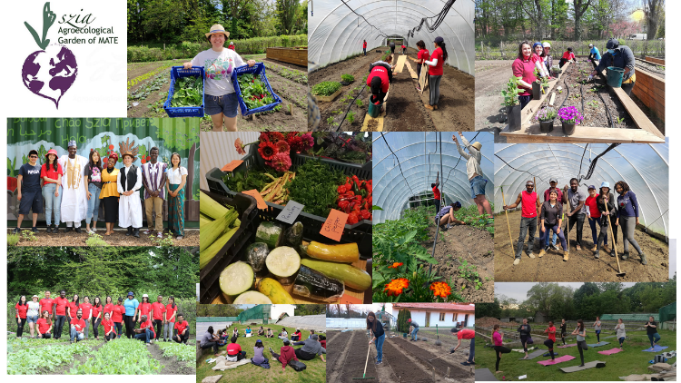
Summer school 2017 Novi Sad
