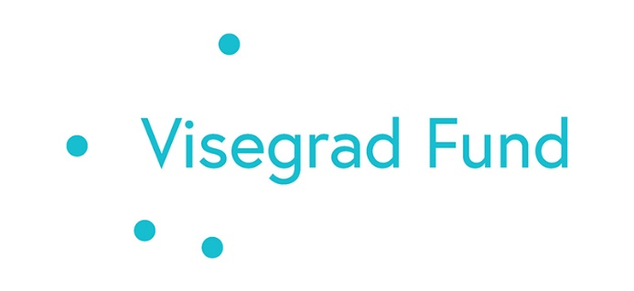
The project is co-financed by the Governments of Czechia, Hungary, Poland and Slovakia through Visegrad Grants from International Visegrad Fund. The mission of the fund is to advance ideas for sustainable regional cooperation in Central Europe.

STRENGTHENING SOFT SKILLS AS EMPLOYMENT KEY TOOL: TRANSFERRING V4 EXPERIENCE
PROJECT PARTNERS
The grant holder and main project coordinator is Armenian National Agrarian University. The Project will be implemented with the support of the following universities from V4 countries:

Hungarian University of Agriculture and Life Sciences (MATE)
Slovak University of Agriculture in Nitra (SUA)
University of South Bohemia (USB)

CONTACT DETAILS
The main coordination of the project is the Head of International Relations Department of ANAU Garegin Hambardzumyan (email: inter-head@anau.am).
The coordinators form V4+ Universities are:
Erika Varga, Hungarian University of Agriculture and Life Sciences (MATE), email: Varga.Erika@uni-mate.hu
Norbert Floris, Slovak University of Agriculture in Nitra (SUA), email: noro.floris@gmail.com
Dagmar Škodová Parmová, University of South Bohemia (USB), email: parmova@ef.jcu.cz

SHORT DESCRIPTION OF THE PROJECT
The project aims to establish a Soft Skills Development Centre (SSDC) at Armenian National Agrarian University (ANAU), with the support of V4 partner universities - Hungarian University of Agriculture and Life Sciences, Slovak University of Agriculture in Nitra and University of South Bohemia). Training in new soft skills modules, developed during the implementation of the project, will increase the chances of employment of the graduates, as well as advance the opportunities of existing professionals during their working life. The implementation period of the project is: 01/01/2022–30/06/2023. The total budget of the Project is 24,015.00 Euro.
Current issues. It is well-known, the labor market needs highly qualified specialists with both professional and soft skills. It is no secret, that soft skills increase the employability of specialists and facilitate their integration into the professional sphere. Soft skills are especially necessary for agricultural professionals, as their work usually involves multiple stakeholders and organizations. All of the above-mentioned activities require the necessary soft skills: leadership, creativity, teamwork, time management, as well as innovative approaches, etc. Sometimes stakeholders organize trainings for new employees or they personally need to find and participate in some kind of training on soft skills. Of course, most of the above-mentioned activities and trainings are paid by new hires.

THE MAIN GOAL OF THE PROJECT
The main goal of this Project is to increase the future employability of the students and professionals in the labor market through the development and improvement of soft skills by providing various modules during formal and informal education. The project will create five modules: Communication skills;
- Communication skills;
- Critical thinking and problem solving;
- Leadership;
- Conflict and time management;
- Teamwork.

Within the framework of the Project ANAU will create a Soft Skills Development Center (SSDC), where students and agricultural specialists will get necessary soft skills competencies during the trainings, organized by ANAU. The above-mentioned modules will be taught at the newly established SSDC. The training will be conducted by the ANAU staff, trained and re-qualified at V4 universities within the framework of this Project. Long-term experience in teaching and learning soft skills of V4 partner universities will be used for the implementation of the project. They will help ANAU create and develop modules as well as train ANAU staff on soft skills teaching.

ADDED VALUE AND INNOVATION ELEMENT OF THE PROJECT
The innovative nature of this project lies in the fact that the appropriate tools are being created at the ANAU for the first time, and it will ensure the sustainability of the formation and development of students’ soft skills. This is the first project at ANAU, the main goal of which is the development of the necessary infrastructure with human and non-human resources to ensure the sustainability of students’ soft skills development. At the same time, it is ANAU’s new approach to promoting education and student employment opportunities to meet the labor-market needs via soft skills development.
In addition, the Soft skills Development Center, which will be the main outcome of this project, will ensure the lifelong learning of professionals working in different areas and interested in developing soft skills. Due to the implementation of this project, the necessary conditions will be created at the ANAU for the development of students’ and current employees’ soft skills. As a result, they will be more competitive in the labor market and will be able to find work easily, as well as get adapted to new working conditions. Moreover, they will show new approaches and critical thinking in solving professional problems. All these competencies will promote their integration into labor environment and the final result will be the increased work outcome. This is the main added value of the proposed Project.

SPECIFIC RESULTS
Specific result | Contribution to the project's overall goal
Established Soft Skills Development Center (SSDC) at  ANAU. | The establishment of SSDC is the main outcome of the project. This Center will organize periodic trainings for students and other internal and external stakeholders (teaching staff; graduates working in the agricultural sphere etc.) on soft skills. Due to this activity, the ANAU will become one of the main centers, where the specialists will be able to participate in both professional training and soft skills training.
Trained teaching staff with skills on teaching soft skills at SSDC. | The staff, trained within the framework of the Project at the V4 universities, will participate in the development and implementation of relevant soft skills modules. They will be the main workforce that will deliver the trainings for the students and other participants, planned within the framework of the SSDC. In addition, the trained staff will also train their other colleagues to ensure the sustainability and continuity of the program
Developed five modules on soft skills training: 1. Communication skills; 2. Critical thinking and problem-solving; 3. Leadership; 4. Conflict and time management; 5. Teamwork․ | The modules will be used for the training of the students and other internal and external participants on soft skills at the established Soft Skills Development Center.
Sustainable international collaboration with V4 partners. | This project brings the ANAU and V4 partner universities together on one board and can promote further cooperation in various fields, as well as the implementation of other international projects.

TARGET GROUPS
The main target groups of the Project are: Bachelor, Master and PhD students of ANAU, academic and administrative staff of ANAU and professionals of the field.

ACTIVITIES AND RESULTS

